Oreobot-Current Design

Previously, we uploaded some images of our robot, Oreobot, which was known as Oreobot 1.0. Now, after some adjustments, design changes, and unexpected situations, we are now looking at Oreobot 1.75. Attached here are some images from various angles of our new design. All of these changes are specific for the first round.

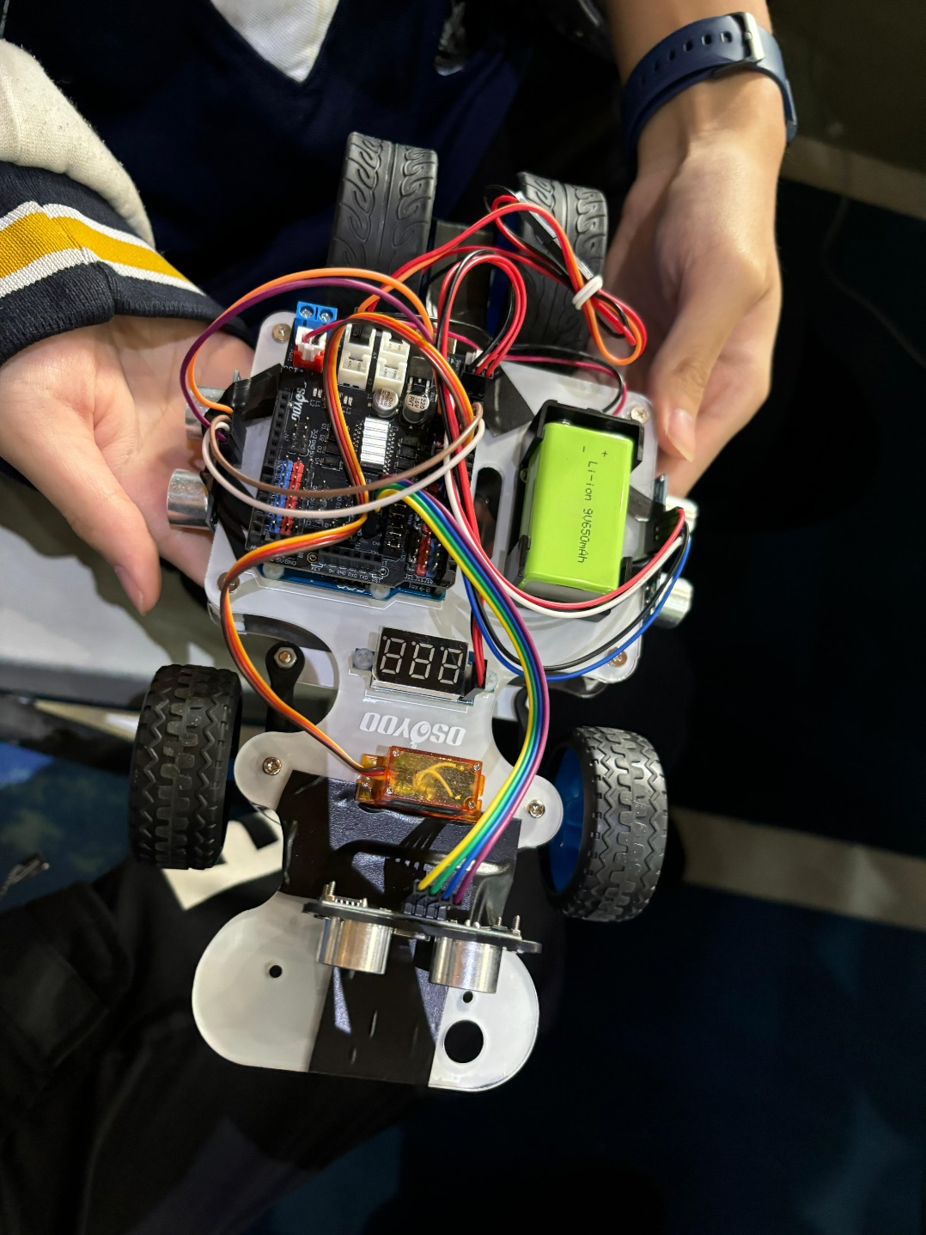

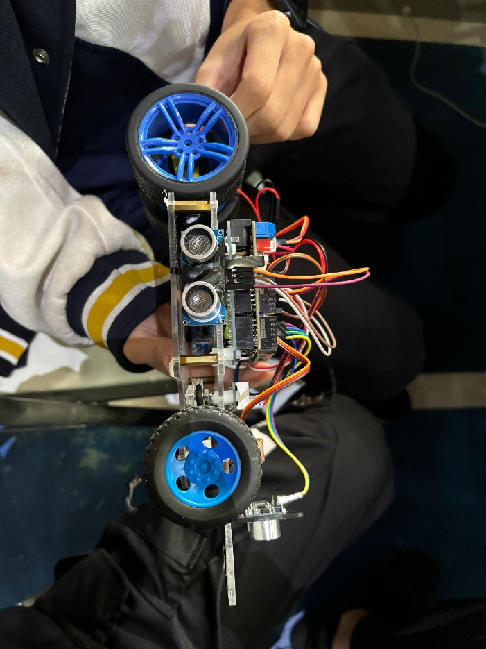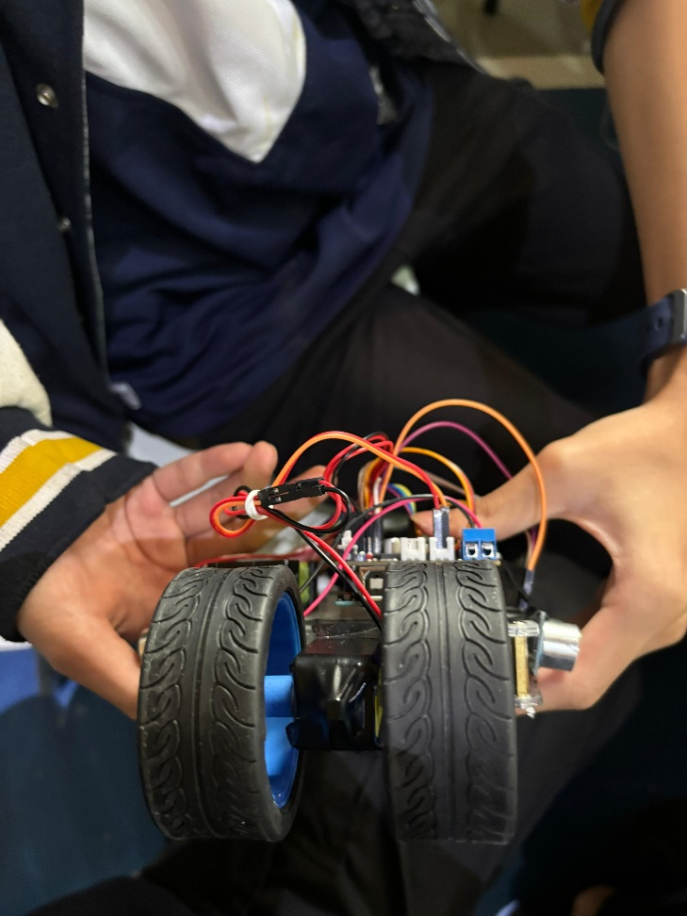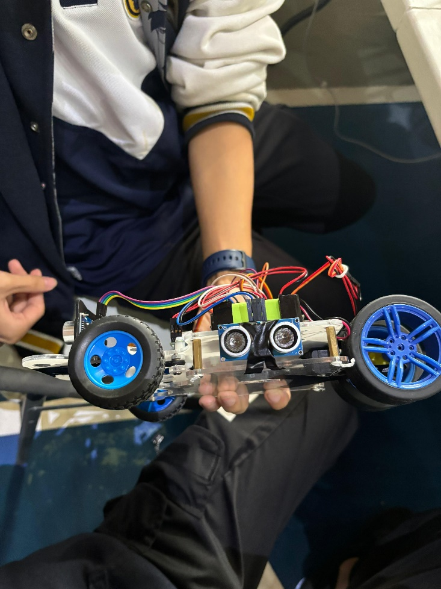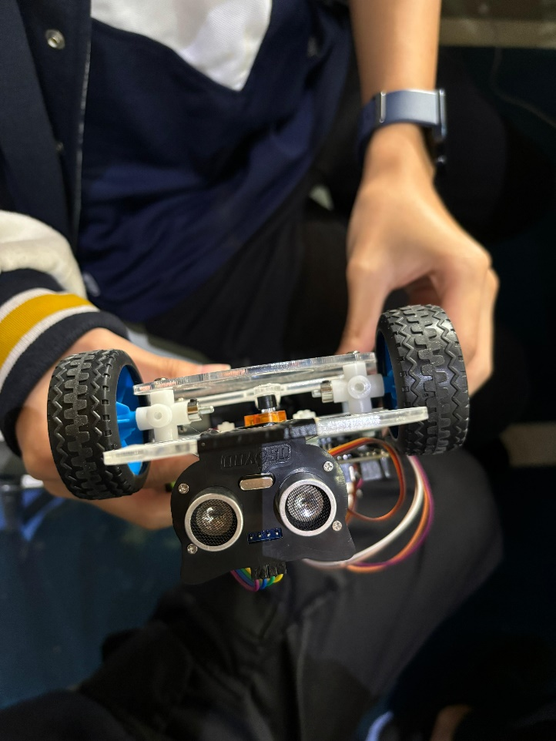

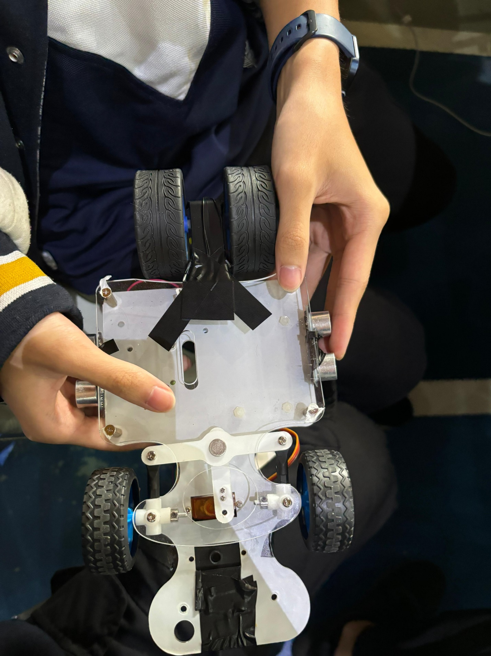

Changelog

* Replaced traction servo for a DC yellow motor.
  + Our previous motor had some problems with the gears, so we decided to change it for a new model and hope for the best.
* Removed part of the bottom acrylic plate in order to remain in the required dimensions
  + We originally had two traction servos on our bot, but since the rules do not allow this, our only option for the robot to remain in the required dimensions was to break part of the acrylic to accommodate this.
* Added two lateral ultrasonic sensors and removed frontal ultrasonic servo
  + Our previous system with one ultrasonic sensor was lacking in precision and reaction time, so we decided to instead implement three sensors to account for all sides simultaneously.
* Code changes
  + Obviously, since hardware changes were made, software changes should follow as well. Code was added for the new sensors, the motor, and some variable optimizations.